**Name: Shaurya Singh Srinet**

**Reg No.: RA2111032010006**

**Branch: CSE w/s in IoT**

**Class: T2**

Object Oriented Design and Programming

Assignment: Week 1: -

1. Write a C++ program that will display the calculator menu. The program will prompt the user to choose the operation choice (from 1 to 5).

Code: -

#include <iostream> using namespace std;

int main()

{

char o; int n1,n2; cout<<"Enter the first number: "; cin>>n1; cout<<"Enter the second number: "; cin>>n2;

cout<<"Enter the operator you want to perform\nAddition: +\nSubtraction: -\nMultiplication:

*\nDivision: /\nModulus: %\n";

cin>>o;

switch (o)

{ case '+':

cout<<"The addition is "<< n1+n2;

break;

case '-': if(n1>n2) cout<<"The subtraction is "<<n1-n2;

else

cout<<"The subtraction is "<<n2-n1;

break;

case '*':

cout<<"The multiplication is "<<n1*n2;

break;

case '/':

cout<<"The division is "<<n1/n2;

break;

case '%':

cout<<"The modulus is "<<n1%n2;

break;

default:

cout<<"Invalid Operator"; break;

}

return 0;

}

Output: -

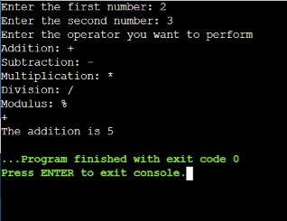

2. Write a C++ program to find those numbers which are divisible by 8 and multiple of 5, between 1000 and 2000 (both included).

Code: -

#include <iostream> using namespace std;

int main()

{ int i;

for(i=1000;i<=2000;i++) if(i%5==0 && i%8==0) cout<<i<<endl;

return 0;

}

Output: -

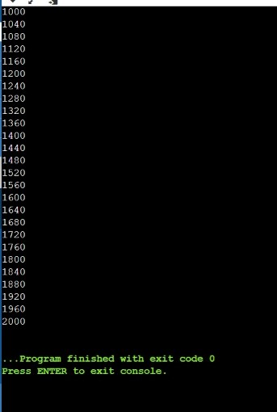

4. Write a function take three numbers from user then output the minimum number.

Code: -

#include <iostream> using namespace std; int main()

{

int n1,n2,n3; cout<<"Enter three numbers to find the smallest one:-\n"; cin>>n1>>n2>>n3; if(n1<=n2 && n1<=n3) cout<<"The smallest is "<<n1; else if(n2<=n1 && n2<=n3) cout<<"The smallest is "<<n2;

else cout<<"The smallest is "<<n3;

return 0;

}

Output: -

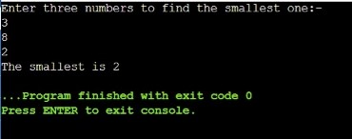

5. Write function that take a string then reverse it.

Code: -

#include <iostream>

#include <cstring>

using namespace std;

void string_rev(string st)

{

int i;

cout<<"The reversed string is: ";

for(i=st.length()-1;i>=0;i--)

cout<<st[i];

}

int main()

{

string s;

int i;

cout<<"Enter the string you want to reverse: ";

cin>>s;

string_rev(s);

return 0;

}

Output: -

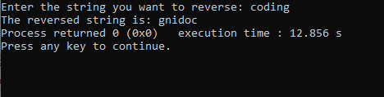

6. Write a C++ program to guess a number between 1 to 9. Note : User is prompted to enter a guess. If the user guesses wrong then the prompt appears again until the guess is correct, on successful guess, user will get a “Well guessed!” message, and the program will exit.

Code: -

#include <iostream> using namespace std;

int main()

{

int g=7,n1,i,n=10; cout<<"Enter the guess between 1 to 9: "; for(i=0;i<n;i++)

{

cin>>n1; if(n1==g) {

cout<<"Well guessed";

break;

} else

cout<<"Guess again!: ";

}

return 0;

}

Output: -

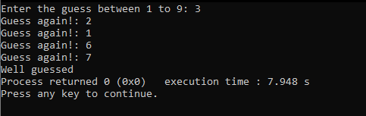

7. Write a C++ program to construct the following pattern, using a nested for loop. *

* *
* * *
* * * *
* * * * *
* * * *
* * *
* *

Code: - #include <iostream> using namespace std; int main()

{ int i,j;

for(i=1;i<5;i++)

{

for(j=1;j<=i;j++)

{

cout<<"*";

}

cout<<endl;

}

for(i=5;i>0;i--)

{ for(j=i;j>0;j--)

{

cout<<"*";

}

cout<<endl;

}

return 0;

}

Output: -

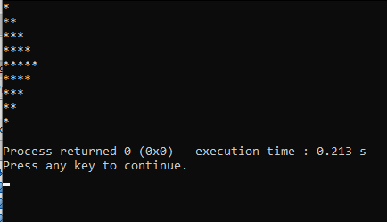

8. Write a C++ program that accepts a word from the user and reverse it. (should not use any functions).

Code: -

#include <iostream> #include <cstring> using namespace std;

int main()

{

string w;

int i;

cout<<"Enter the string you want to reverse: "; cin>>w; cout<<"The reversed string is: "; for(i=w.length()-1;i>=0;i--) cout<<w[i]; return 0;

}

Output: -



12.Write a C++ program to find numbers between 100 and 400 (both included) where each digit of a number is an even number. The numbers obtained should be printed in a comma-separated sequence.

Code: -

#include <iostream> using namespace std; int main()

{ int n1,n2,i,r; for(i=100;i<400;i++)

{

r=i%10; n1=(i/10)%10; n2=(i/100)%10; if(r%2==0&&n1%2==0&&n2%2==0)

{

cout<<i<<", ";

i++;

}

}

return 0;

}

Output: -

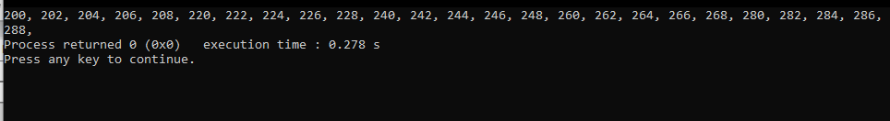

14.Write a C++ program to sum of two given integers. However, if the sum is between 105 to 200 it will return 200.

Code: -

#include <iostream> using namespace std;

int main()

{

int n1,n2,s; cout<<"Enter the two numbers you want to add: -\n"; cin>>n1>>n2; s=n1+n2; if(s>=105&&s<=200) cout<<"The sum is 200";

else

cout<<"The sum is "<<s; return 0;

}

Output: -

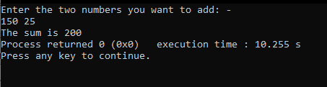

15. Write a C++ program to construct the following pattern, using a nested loop number.

Expected Output:

999999999

88888888

7777777

666666

55555

4444

333

22

1

Code: -

#include <iostream>

using namespace std; int main()

{ int n1,i,j; cin>>n1; for(i=n1;i>0;i--)

{ for(j=i;j>0;j--)

{

cout<<i;

}

cout<<endl;

}

return 0;

}

Output: -

